CPS470570: Computer Networks and Security
Written Homework 4

Total Points: 100

Note: In all written assignments, please show as much of your work as you can. Even if you get a wrong answer, you can get partial credit if you show your work. If you make a mistake, it will also help the grader show you where you made a mistake. You can either type your answers in the solution area and submit the file directly on Isidore or hand-write your answers and get a scanned version of it to submit on Isidore. If you find the default space is not sufficient for you to type/handwrite your answers, please feel free to enlarge the space as needed. Please make sure your handwriting is clear and understandable. If the grader or I cannot understand your handwriting, you get zero for your solutions.

***The current total points is 77 points for all the questions, and everyone gets the rest 23 points for free!***

Problem 1[12 points]: Computing TCP's RTT and timeout values
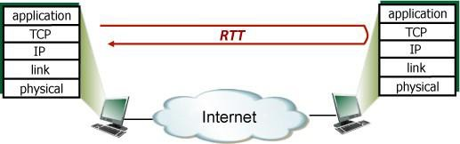

Suppose that TCP's current estimated values for the round- t r i p time (estimatedRTT) and deviation in the RTT (DevRTT) are 200 msec and 34 msec, respectively (see transport layer slides for a discussion of these variables). Suppose that the next three measured values of the RTT are 220, 370, and 250 respectively.

Compute TCP's new value of estimatedRTT, DevRTT, and the TCP timeout value after each of these three measured RTT values is obtained.Use the values of α = 0.125 and β = 0.25.

Solution:
After the first RTT estimate is made: [4 points]
estimatedRTT = 0.875*200 + 0.125*220 = 202.5 msecs
DevRTT = 0.75*34 + 0.25*(abs(220 - 202.5)) = 29.875 msecs
TimeoutInterval = 202.5 + 4*29.875 = 322 msecs

After the second RTT estimate is made: [4 points]
estimatedRTT = 0.875*202.5 + 0.125*370 = 223.4375 msecs
DevRTT = 0.75*29.875 + 0.25*(abs(370 - 223.4375)) = 59.046875 msecs
TimeoutInterval = 223.4375 + 4*59.046875 = 459.625 msecs After the third RTT estimate is made: [4 points]
estimatedRTT = 0.875*223.4375 + 0.125*370 = 226.7578125 msecs
DevRTT = 0.75*59.046875 + 0.25*(abs(250 - 226.7578125)) = 59.046875 msecs
TimeoutInterval = 226.7578125 + 4*50.095703125 = 427.140625 msecs

Problem 2 [12 points]: TCP in action: slow start, congestion avoidance, and fast retransmit.

Consider the figure below, which plots the evolution of TCP's congestion window at the beginning of each time unit (where the unit of time is equal to the RTT); Please review the transport layer slides. In the abstract model for this problem, TCP sends a "flight" of packets of size cwnd at the beginning of each time unit. The result of sending that flight of packets is that either (i) all packets are ACKed at the end of the time unit, (ii) there is a timeout for the first packet, or (iii) there is a triple duplicate ACK for the first packet. In this problem, you are asked to reconstruct the sequence of events (ACKs, losses) that resulted in the evolution of TCP's cwnd shown below.
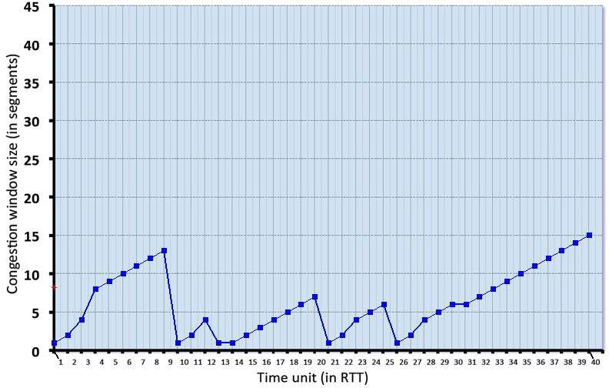

Consider the evolution of TCP's congestion window in the example above and answer the following questions. The initial value of cwnd is 1 and the initial value of ssthresh (shown as a red +) is 8.

- Give the times at which TCP is in slow start, congestion avoidance and fast recovery at the start of a time slot, when the flight of packets is sent.
- Give the times at which the first packet in the sent flight of packets is lost, and indicate whether that packet loss is detected via timeout, or by triple duplicate ACKs.
- Give the times at which the value of ssthresh changes, and give the new value of
ssthresh.

Solution:
The solution is shown in the figure below. For intervals of time when TCP is in slow start, the plotted value of cwnd is shown as a green square [4 points]. For intervals of time when TCP is in congestion avoidance [4 points], the plotted value of cwnd is shown as a yellow square. For intervals of time when TCP is in fast recovery [4 points], the plotted value of cwnd is shown as an orange square. The values for ssthresh are shown following a change, as a red plus sign. A flight of packets experiencing a loss has the loss type (which determines the next value of cwnd labeled above.
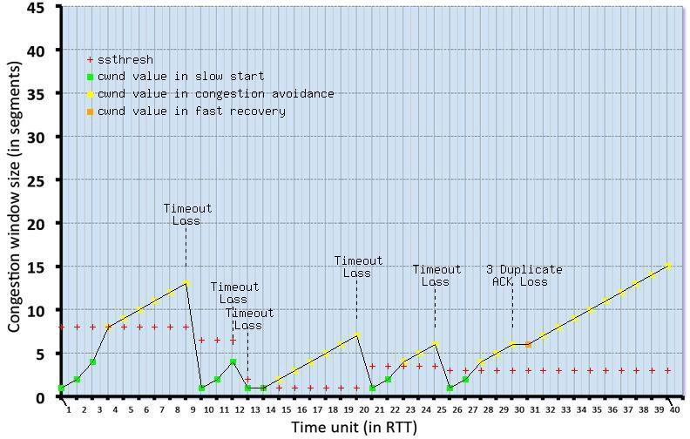

Problem 3[13 points]: Consider a datagram network using 32-bit host addresses. Suppose a router has four links, numbered 0 through 3, and packets are to be forwarded to the link interfaces as follows:

Destination Address Range Link Interface
11100000  through 11100000 | 00000000  00111111 | 00000000  11111111 | 00000000  11111111 | 0
11100000  through 11100000 | 01000000  01000000 | 00000000  11111111 | 00000000  11111111 | 1
11100000  through 11100001 | 01000001  01111111 | 00000000  11111111 | 00000000  11111111 | 2
otherwise |  |  |  | 3

- Provide a forwarding table that has five entries, uses longest prefix matching, and forwards packets to the correct link interfaces.
- Describe how your forwarding table determines the appropriate link interface for datagrams with destination addresses:
11001000 10010001 01010001 01010101
11100001 01000000 11000011 00111100
11100001 10000000 00010001 01110111

Solution:
- Answer: [10 points]

Prefix Match Link Interface
11100000 | 00 | 0
11100000 | 01000000 | 1
11100000 | 01 | 2
11100001 | 1 | 3
otherwise |  | 3

- Answer: [3 points]

Prefix match for first address is 5th entry: link interface 3 Prefix match for second address is 3nd entry: link interface 2 Prefix match for third address is 4th entry: link interface 3

Problem 4: [21 points]Addressing
Consider the router and the three attached subnets below (A, B, and C). The number of hosts is also shown below. The subnets share the 23 high-order bits of the address space: 10.190.54.0/23.
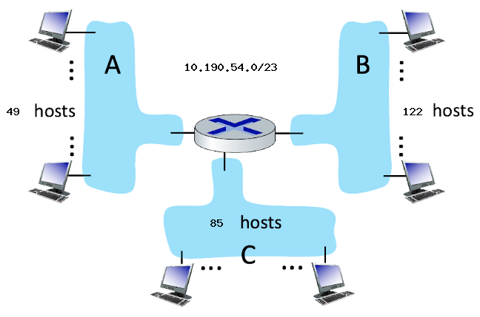

Assign subnet addresses to each of the subnets (A, B, and C) so that the amount of address space assigned is minimal, and at the same time leaving the largest possible contiguous address space available for assignment if a new subnet were to be added. Then answer the questions below. Please use decimal format to answer the following questions. You can find the conversion table between binary to decimal at the end of the exam paper. Moreover, for your reference, 2³=8, 2⁴=16, 2⁵=32, 2⁶=64, 2⁷=128, 2⁸=256.

- [3 points] How many hosts can there be in this address space without considering the specific network topology in the figure? (Note: you need to list the formula)
Answer:

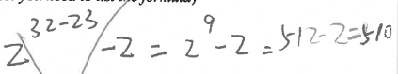

- [4 points]What is the subnet address of subnet B? (CIDR notation) (Note: you need to provide an analysis about how to get your answer otherwise you get zero points. Please make sure your answer is brief.)
Answer:

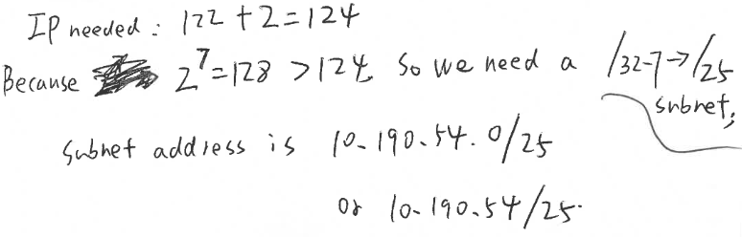

- [2 points]What is the broadcast address of subnet B?
Answer:
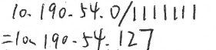

- [2 points]What is the first host IP address of subnet B?
Answer:
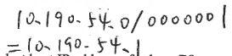
- [2 points]What is the last host IP address of subnet B?
Answer:
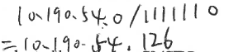

- [4 points]What is the subnet address of subnet C? (CIDR notation)? (Note: you need to provide an analysis about how to get your answer otherwise you get zero points. Please make sure your answer is brief.)
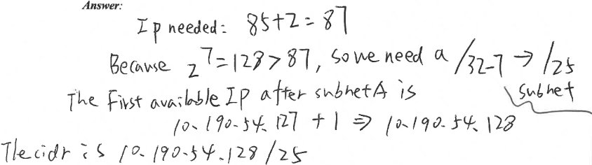

- [4 points]What is the subnet address of subnet A? (CIDR notation)? (Note: you need to provide an analysis about how to get your answer otherwise you get zero points. Please make sure your answer is brief.)
Answer:

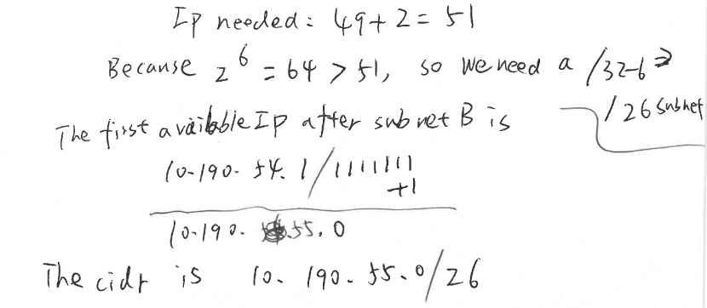

Problem 5: [8 points] NETWORK ADDRESS TRANSLATION.
Consider the scenario below in which three hosts, with private IP addresses 10.0.1.10, 10.0.1.17, 10.0.1.21 are in a local network behind a NAT'd router that sits between these three hosts and the larger Internet. IP datagrams being sent from, or destined to, these three hosts must pass through this NAT router. The router’s interface on the LAN side has IP address 10.0.1.26, while the router’s address on the Internet side has IP address 135.122.192.206.
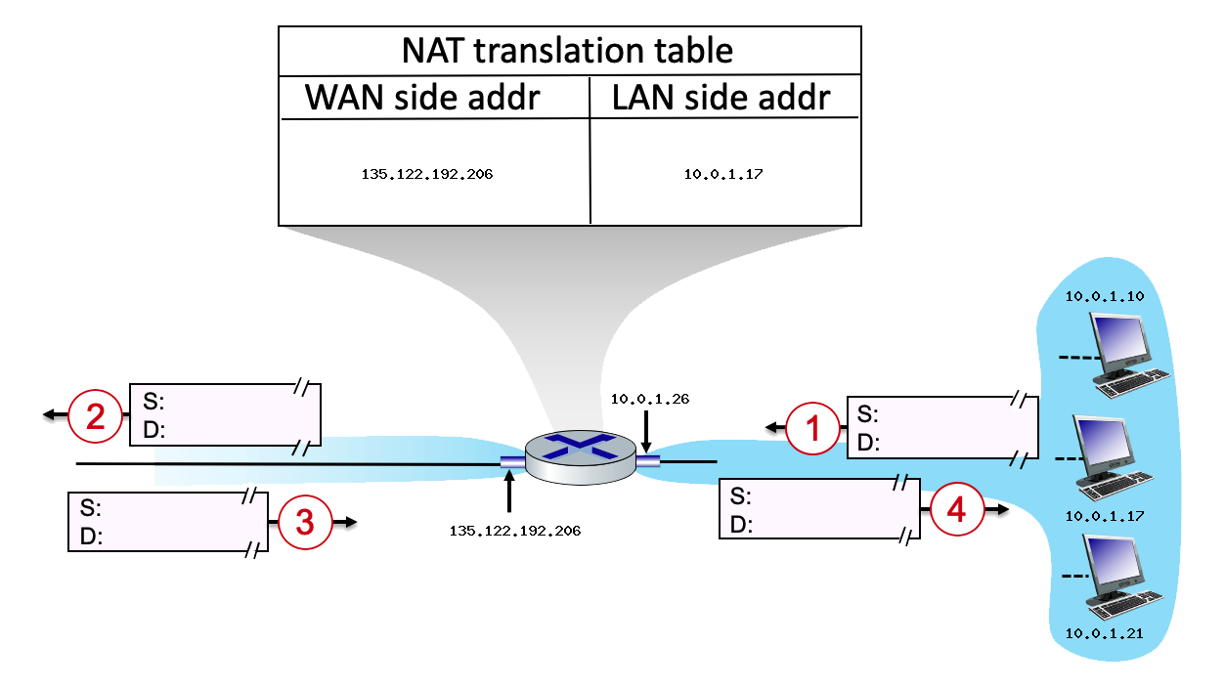
Suppose that the host with IP address 10.0.1.17 sends an IP datagram destined to host 128.119.169.190. The source port is 3490, and the destination port is 80.

Please provide the S (source) and D (destination) for 1, 2, 3, and 4 step in the above figure.

Solution:
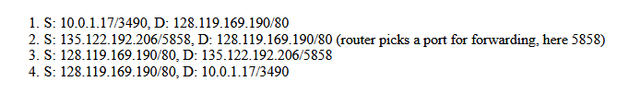

- S: 10.0.1.17/3490, D: 128.119.169.190/80

- S: 135.122.192.206/5858, D: 128.119.169.190/80 (router picks a port for forwarding, here 5858, students can choose other port #)

- S: 128.119.169.190/80, D: 135.122.192.206/5858

- S: 128.119.169.190/80, D: 10.0.1.17/3490

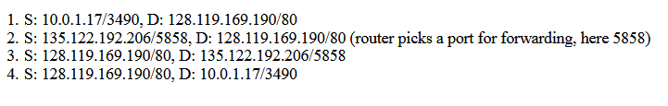

Problem 6: [11 points] IPV6 TUNNELING AND ENCAPSULATION.

Consider the network shown below which contains four IPv6 subnets, connected by a mix of IPv6-only routers (shaded blue), IPv4-only routers (shaded red) and dual-capable IPv6/IPv4 routers (shaded blue with red interfaces to IPv4 routers).

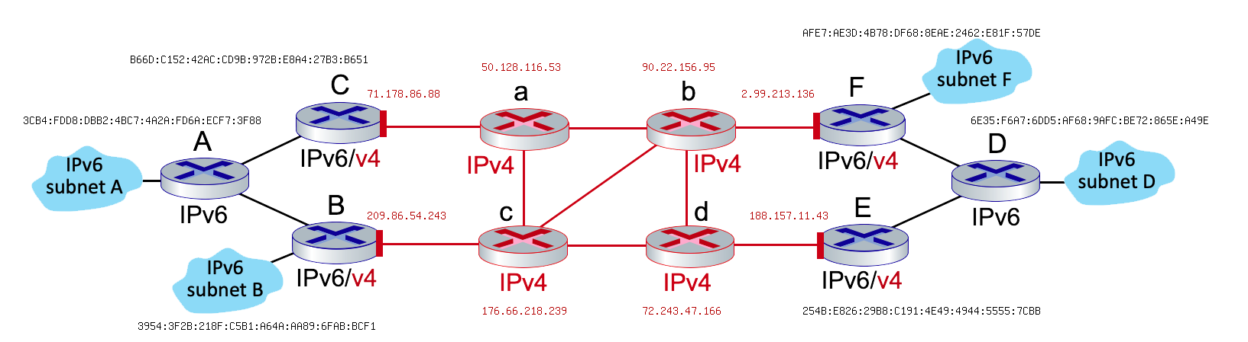

Suppose that a host of subnet B wants to send an IPv6 datagram to a host on subnet D. Assume that the forwarding between these two hosts goes along the path: B --> c --> d --> E --> D

Answer the following questions:
- What is the source address of this B to c datagram?
- What is the destination address of this B to c datagram?
- What is the source address of this encapsulated datagram inside this B to c datagram?
- What is the destination address of this encapsulated datagram inside this B to c datagram?
- What is the source address of this c to d datagram?
- What is the destination address of this c to d datagram?
- What is the source address of this encapsulated datagram inside this c to d datagram?
- What is the destination address of this encapsulated datagram inside this c to d datagram?
- What is the source address of this E to D datagram?
- What is the destination address of this E to D datagram?
- Is this E to D datagram encapsulating another datagram? Yes or No.

Solution:

- What is the source address of this B to c datagram? Answer: 209.86.54.243
- What is the destination address of this B to c datagram? Answer: 188.157.11.43
- What is the source address of this encapsulated datagram inside this B to c datagram?
Answer: 3954:3F2B:218F:C581:A64A:AA89:6FAB:BCF1
- What is the destination address of this encapsulated datagram inside this B to c datagram?
Answer: 6E35:F6A7:6005:AF68:9AFC:BE72:865E:A49E
- What is the source address of this c to d datagram?
Answer: 209.86.54.243
- What is the destination address of this c to d datagram?
Answer: 188.157.11.43
- What is the source address of this encapsulated datagram inside this c to d datagram?
Answer: 3954:3F2B:218F:C581:A64A:AA89:6FAB:BCF1
- What is the destination address of this encapsulated datagram inside this c to d datagram?
Answer: 6E35:F6A7:6005:AF68:9AFC:BE72:865E:A49E
- What is the source address of this E to D datagram?
Answer: 3954:3F2B:218F:C581:A64A:AA89:6FAB:BCF1
- What is the destination address of this E to D datagram?
Answer: 6E35:F6A7:6005:AF68:9AFC:BE72:865E:A49E

Is this E to D datagram encapsulating another datagram? Yes or No. Answer: NO

